Table of Contents

1. Test Approach 2

2. Test Case Design 2

3. Test Environment: 2

4. Test Execution: 8

5. Test Monitoring and Reporting 12

6. Performance Tool Integration with CI/CD 20

7. Performance Test Tool as JMeter. 21

This Document provides the details about how to provide the API Testing

API testing is Performed based on set of documents starting from Test Cases, Test plan/Test strategy, Traceability matrix,

# Test Approach

The Semaphore API will be Tested using Postman.

# Test Case Design

1. In this stage Test cases are Written in ADO based on the requirements for Semaphore API Features.
2. All the test cases are Mapped to the requirements or features using traceability matrix.
3. API tests are Written in Postman, based on test cases.
4. API Tests are Mapped with test case in ADO or using traceability matrix.

# Test Environment:

In this stage we will prepare the test environment using the postman tool and configuring the Semaphore API, Data base to refer the row in a table, turbine UI to trigger the graphs.

The above screen shot shows the process run key present in the Semaphore DB.

The Above Screenshot shows the process key present in the Turbine UI.

How to configure JMeter Test Plan for Semaphore API Performance Testing.

1. Go to JMETER_HOME/bin and start JMeter with jmeterw.cmd on

Select File 🡪New 🡪 Test Plan on JMeter

2. Select “Test Plan” on the tree

Rename Test Plan as Performance_Semaphore_API as mentioned in the below snapshot

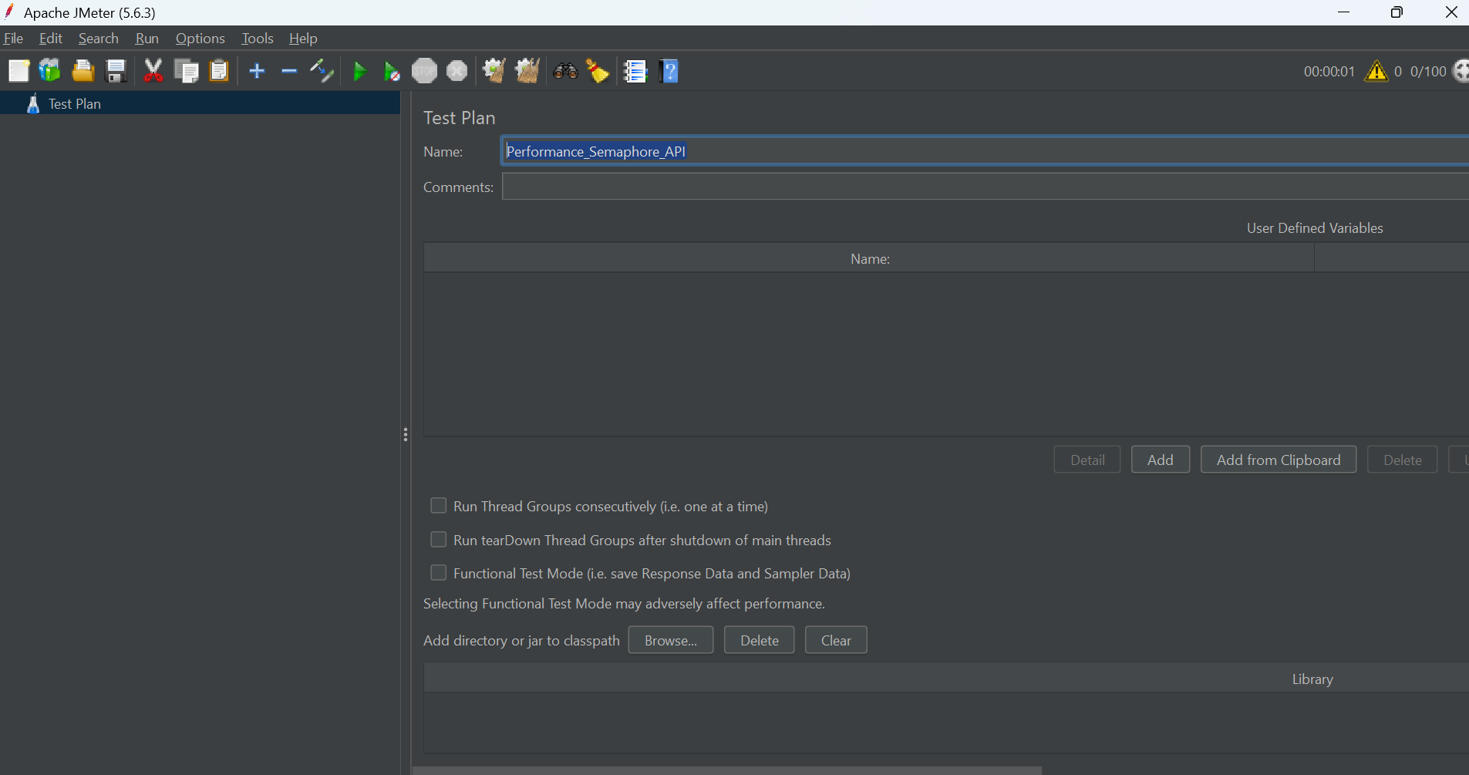

3. Right click on the “Performance_Semaphore_API” and add a Sampler 🡪 HTTP Request.

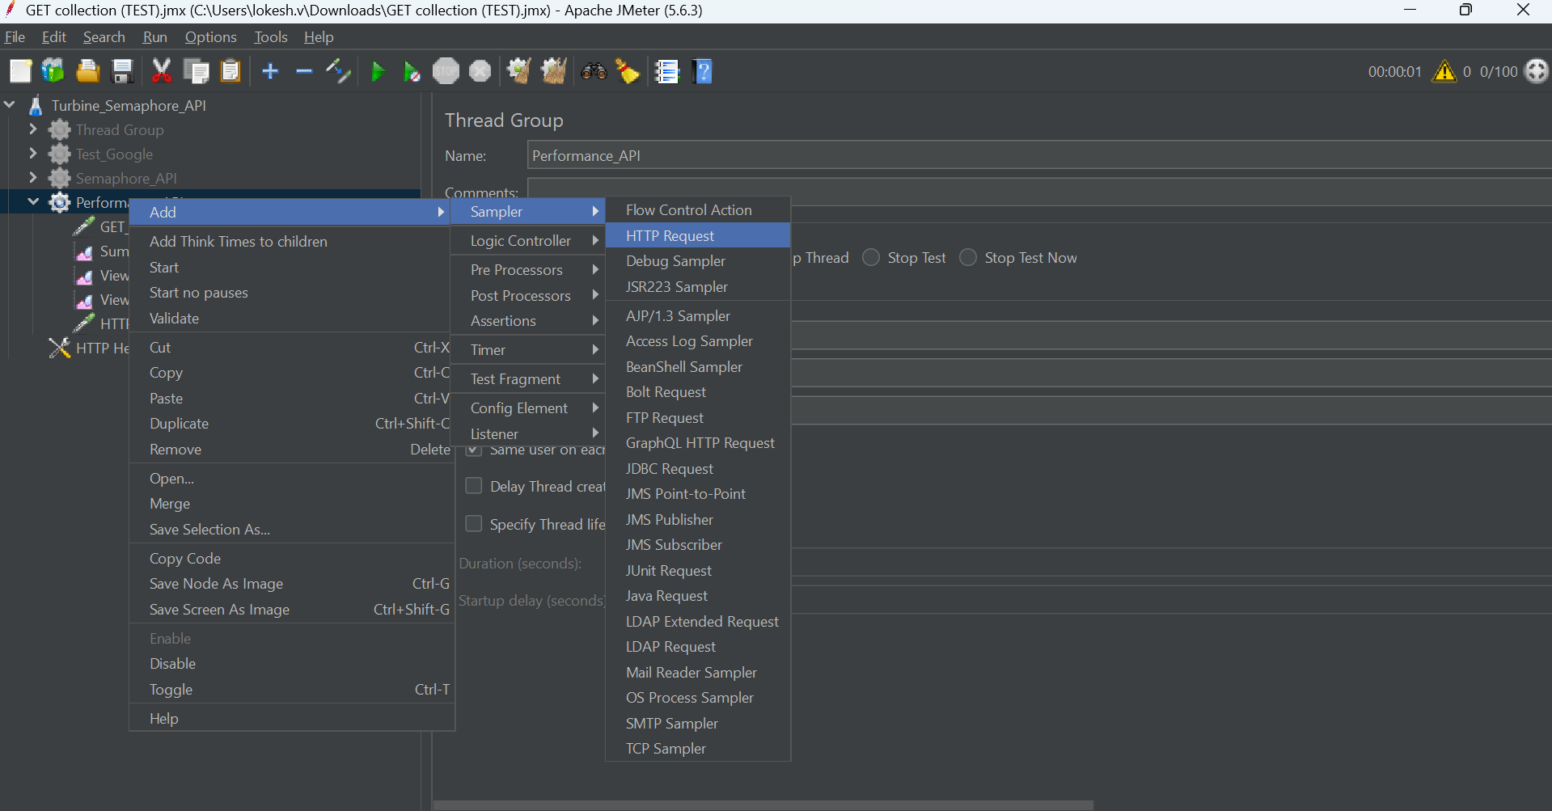4. Rename as mentioned below snapshot to HTTP Header Manager.

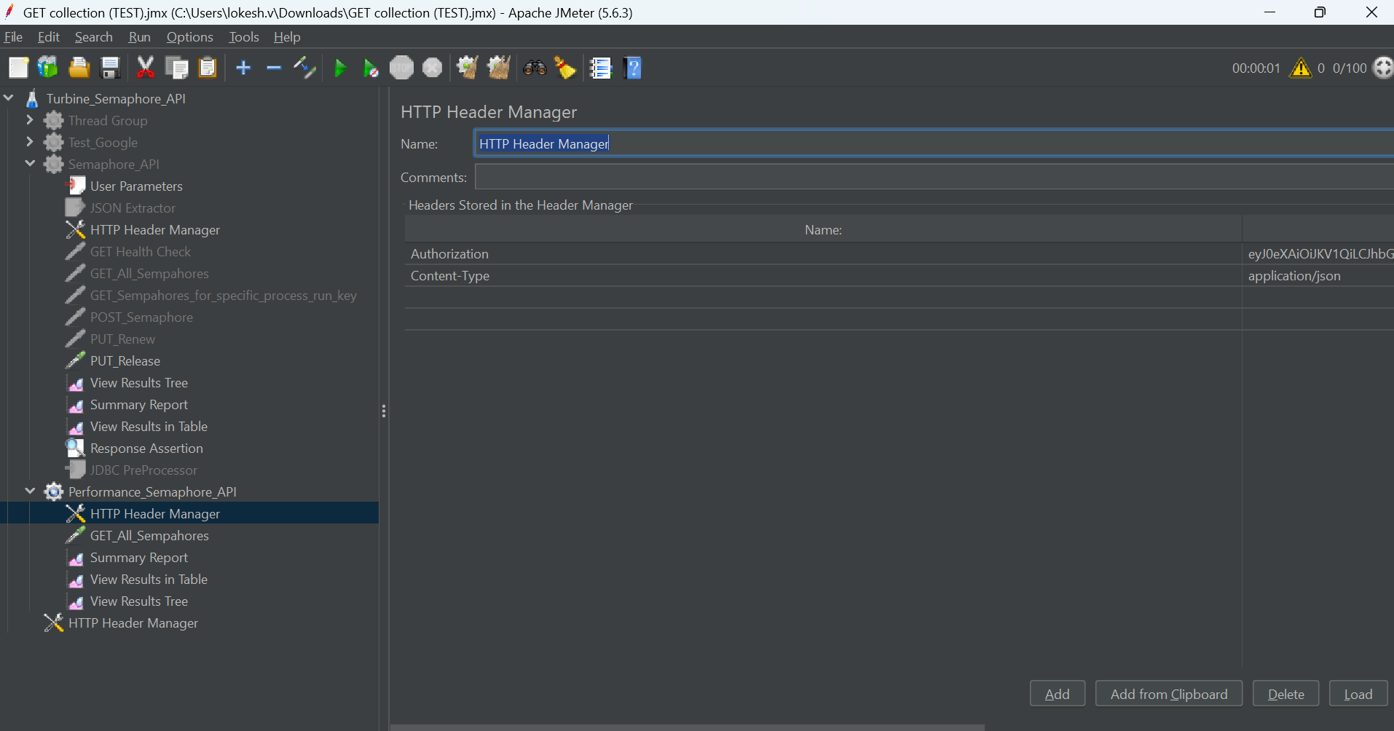

1. Add Authorization and content type along with the values for the same.

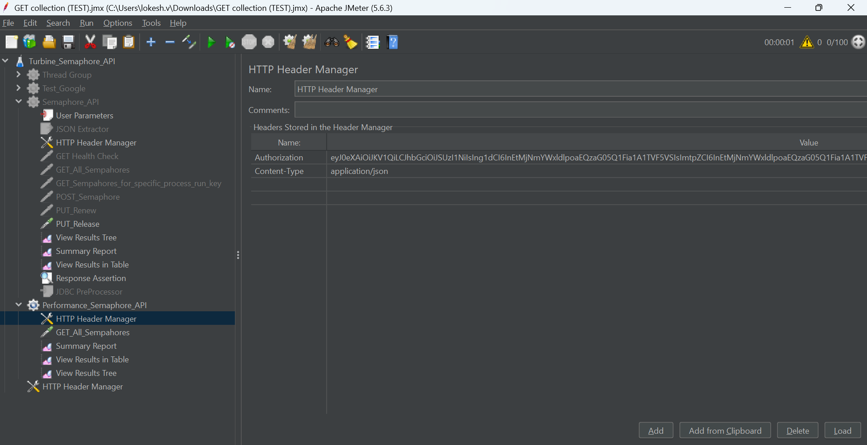

1. Right click on the Performance_Semaphore_API 🡪 Sample 🡪 HTTP Request



1. Rename as GET_ALL_Semaphores as mentioned in below snapshot.

1. Make sure you add all the details mentioned in the below snapshot.

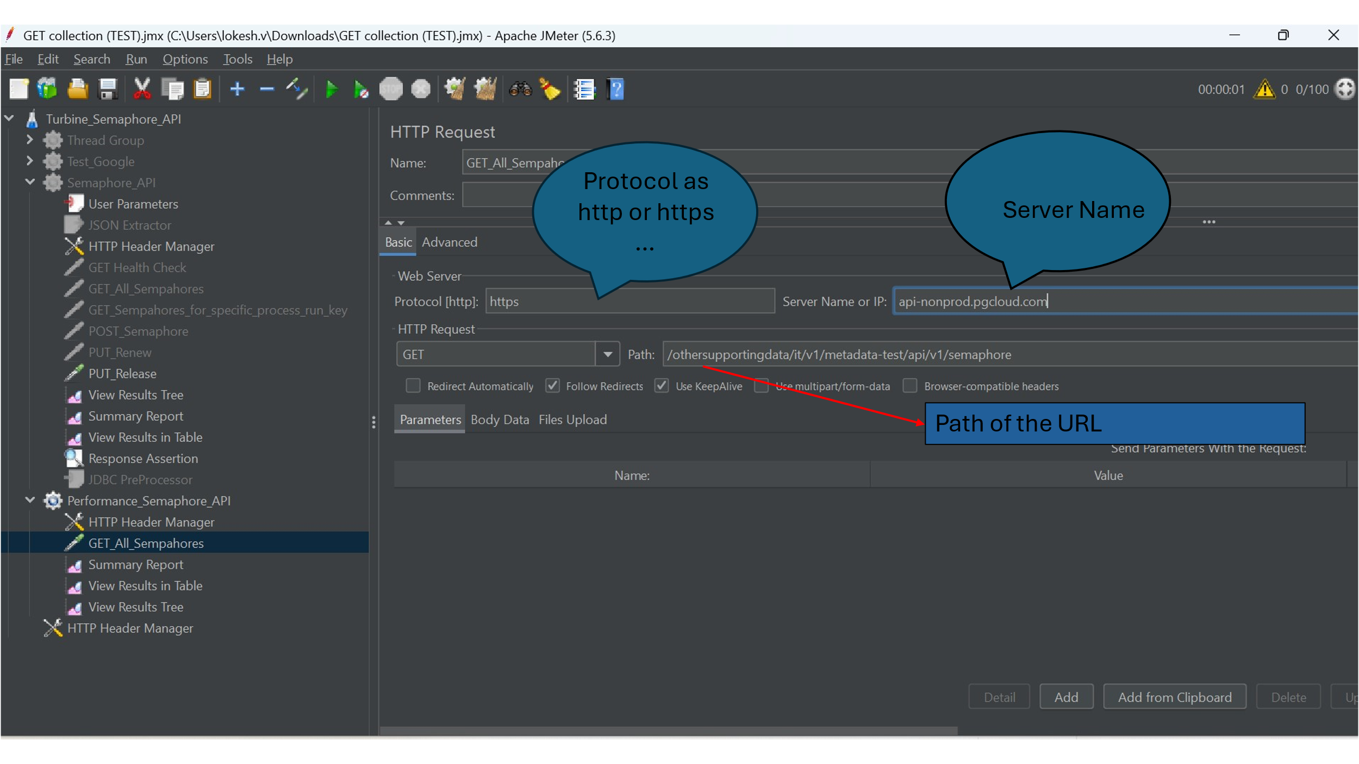

1. Right click on the Performance_Semaphore_API and ADD🡪 Listener🡪 View Result Tree.

Below snapshot shows how to add listener to capture the results.

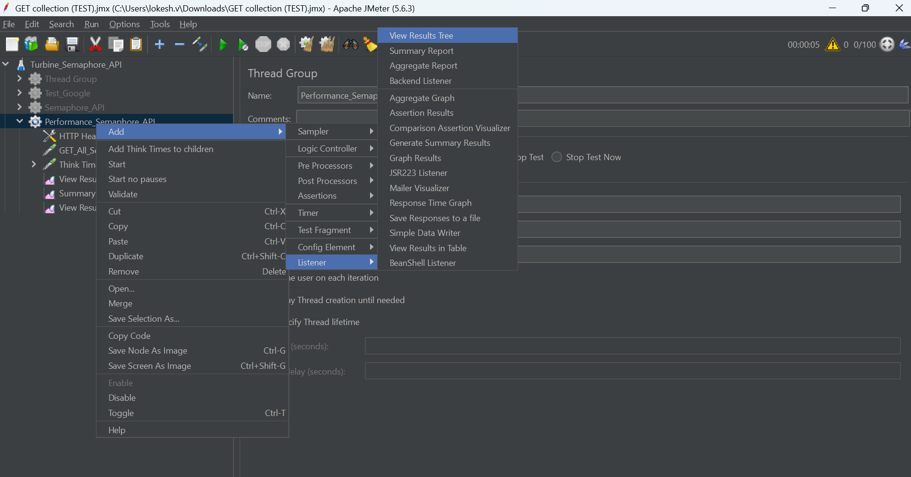

1. You can add as different listeners like summary report , View Results in Table which we used for capturing the results in our examples.

# Test Execution:

In This Stage We run the test case and Get the Performance metrics for the simple GET all Semaphores for 20 virtual users.

Here are a few examples of semaphore API methods used where in client sends the request and server response to measure the performance for 20 Users.

1. GET Request for all semaphores.

After configuring all the parameters and necessary listeners we need to click on the start/run button as shown in below snapshot.

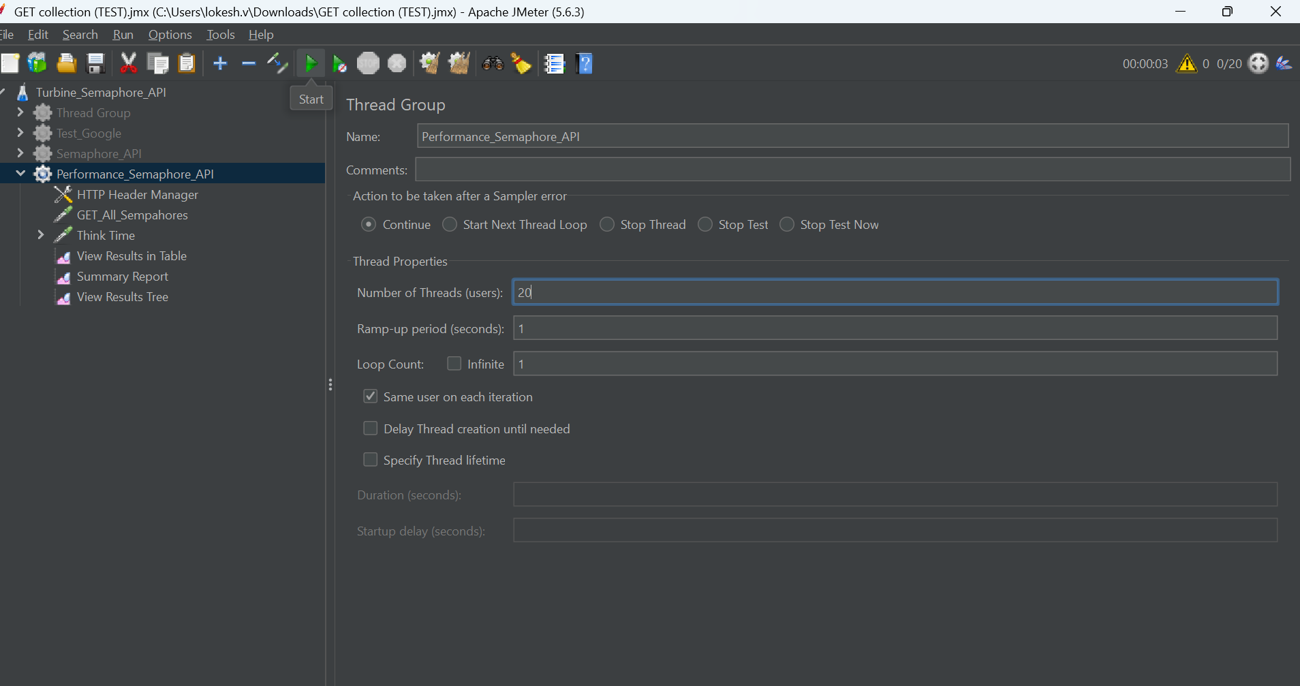

After running the API for 20 users, click on the **View Results in Table**, below is the example for 20 users, different metrics captured during the test execution, we can see the different values performance metrics in the snapshot.

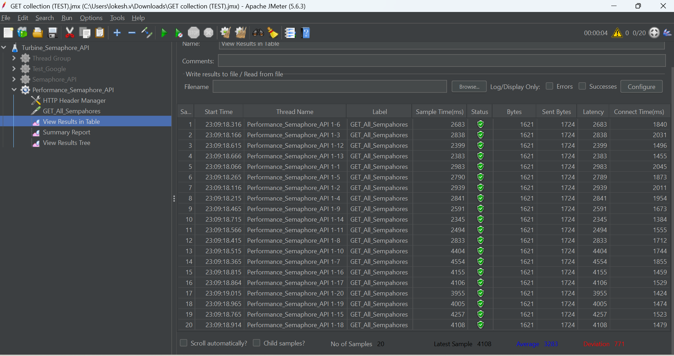

Below are the snapshot results of the **Summary Report** and different Performance metrics captured as summary Report for **20 Virtual Users**.

Below is the Performance metrics results in **View Results Tree** format which captured for individual performance metrics for **20 Virtual Users**.

Below is the Performance Request body sent for each individual Virtual user.

Below snapshot is the Response body displayed for each individual performance measured as part of performance metrics.

# Test Monitoring and Reporting

This is the final stage where we monitor the results and report the test results to the stakeholders through email. We generate the detailed reports from the JMeter Results for different Virtual Users in below examples we have covered incrementing of 20 users from each cycle and capture the results from 20 Virtual Users to 100 users and for each increment we capture the results as mentioned below which include benchmarks for each increment.

After running the **API for 40 users**, click on the **View Results in Table**, below is the example for 40 users, different metrics captured during the test execution, we can see the different values performance metrics in the snapshot.

Below are the snapshot results of the Summary Report, and different Performance metrics captured as summary Report for **40 Users**.

Below is the Performance metrics results in **View Results Tree** format which captured individual sample result performance metrics for **40 Virtual Users**.

Below is the Request Body sent for each individual Virtual User.

Below snapshot shows the Response Body for each individual Virtual User.

After running the API for 60 users, click on the View Results in Table, below is the example for 60 users, different metrics captured during the test execution, we can see the different values performance metrics in the snapshot.

After running the **API for 60 users**, click on the **View Results in Table**, below is the example for 60 users, different metrics captured during the test execution, we can see the different values performance metrics in the snapshot.

Below are the snapshot results of the **Summary Report** and different Performance metrics captured as summary Report for **60 Virtual Users**.

After running the API for 80 users, click on the View Results in Table, below is the example for 80 users, different metrics captured during the test execution, we can see the different values performance metrics in the snapshot.

Below are the snapshot results of the **Summary Report** and different Performance metrics captured as summary Report for **80 Virtual Users**.

After running the **API for 80 users**, click on the **View Results in Table**, below is the example for 80 users, different metrics captured during the test execution, we can see the different values performance metrics in the snapshot.

After running the API for 100 users, click on the View Results in Table, below is the example for 100 users, different metrics captured during the test execution, we can see the different values performance metrics in the snapshot.

After running the **API for 100 users**, click on the **View Results in Table**, below is the example for 100 users, different metrics captured during the test execution, we can see the different values performance metrics in the snapshot.

Below are the snapshot results of the **Summary Report** and different Performance metrics captured as summary Report for **100 Virtual Users**.

The Above Screenshot shows the Execution results for monitoring and reporting how it looks in JMeter to be considered as example only.

# Performance Tool Integration with CI/CD

JMeter has documented the integration with Jenkins here Jenkins is used for example purposes only , we can integrate with any CI/CD tool. We just need to enable the plugin and follow the steps to achieve the integration. [Using JMeter with Jenkins](https://www.jenkins.io/doc/book/using/using-jmeter-with-jenkins/)

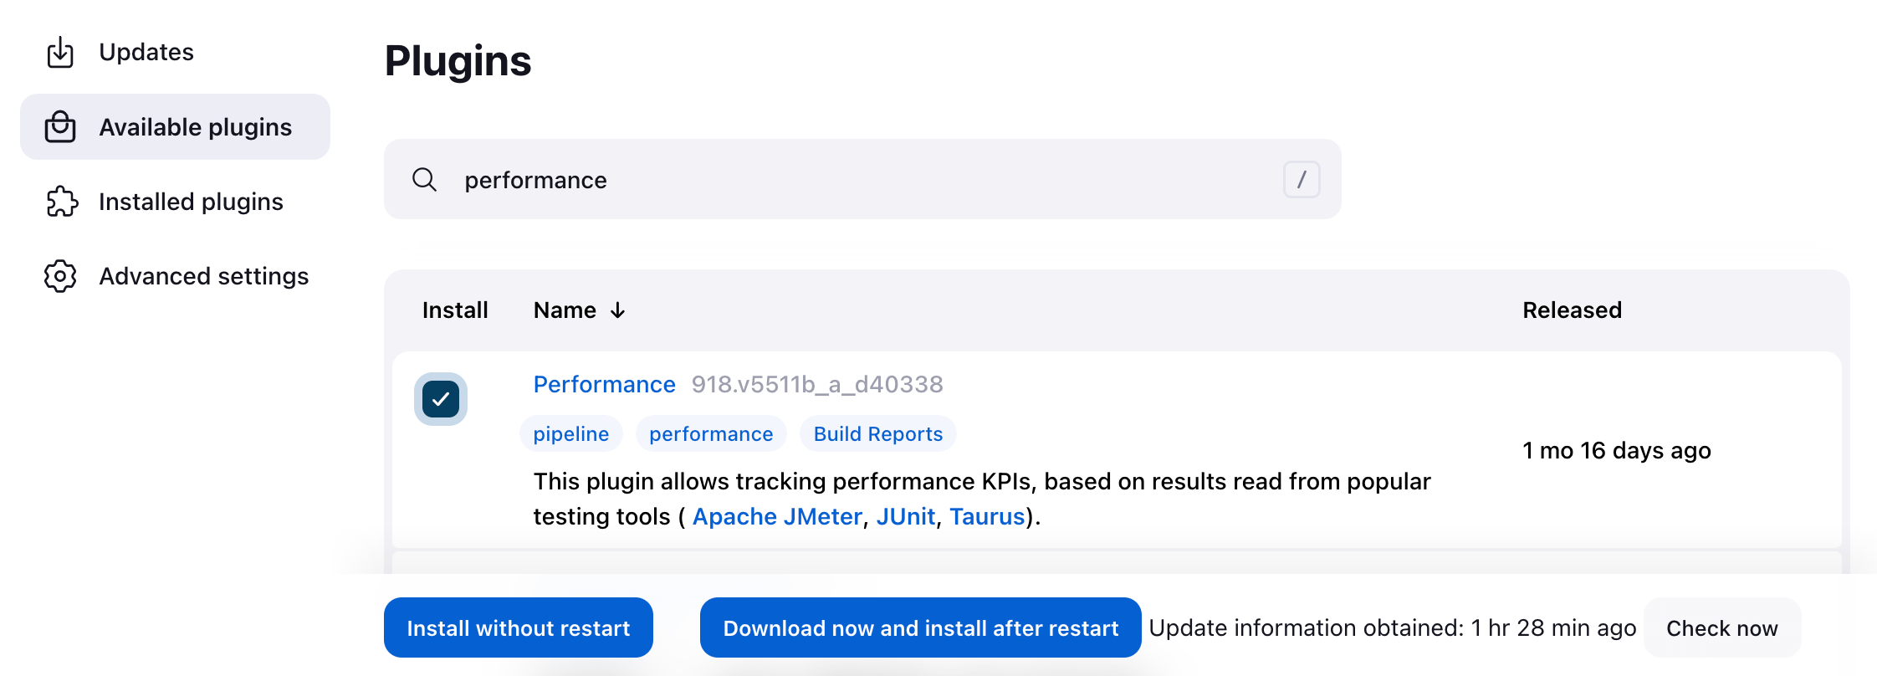

# Performance Test Tool as JMeter.

How to use the tool to support testing please follow the below link

<https://jmeter.apache.org/usermanual/jmeter_proxy_step_by_step.html>